**EXPERIMENT NO: 1**

**Aim:**

Create an Employee Table with the help of Data Mining Tool WEKA.

# Description:

We need to create an Employee Table with training data set which includes attributes like name, id, salary, experience, gender, phone number.

# Procedure:

**Steps:**

1. Open Start → Programs → Accessories → Notepad
2. Type the following training data set with the help of Notepad for Employee Table.

@relation employee @attributename{x,y,z,a,} @attribute id numeric

@attribute salary {low,medium,high}

@attribute exp numeric

@attribute gender {male,female}

@attribute phone numeric

@data x,101,low,2,male,250311 y,102,high,3,female,251665 z,103,medium,1,male,240238 a,104,low,5,female,200200 b,105,high,2,male,240240

1. After that the file is saved with **.arff** file format.
2. Minimize the arff file and then open Start → Programs → weka-3-4.
3. Click on **weka-3-4**, then Weka dialog box is displayed on the screen.
4. In that dialog box there are four modes, click on **explorer**.
5. Explorer shows many options. In that click on **‘open file’** and select the arff file
6. Click on **edit button** which shows employee table on weka.

# Training Data Set → Weather Table

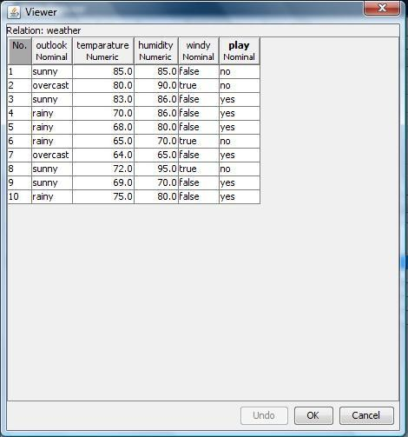

**Result:**

This program has been successfully executed.

**EXPERIMENT NO:2**

**Aim:**

Create a Weather Table with the help of Data Mining Tool WEKA.

# Description:

We need to create a Weather table with training data set which includes attributes like outlook, temperature, humidity, windy, play.

# Procedure:

**Steps:**

1. Open Start → Programs → Accessories → Notepad
2. Type the following training data set with the help of Notepad for Weather Table.

@relation weather

@attribute outlook {sunny,rainy,overcast}

@attribute temparature numeric @attribute humidity numeric

@attribute windy {true,false}

@attribute play {yes,no}

@data sunny,85.0,85.0,false,no overcast,80.0,90.0,true,no sunny,83.0,86.0,false,yes rainy,70.0,86.0,false,yes rainy,68.0,80.0,false,yes rainy,65.0,70.0,true,no overcast,64.0,65.0,false,yes sunny,72.0,95.0,true,no sunny,69.0,70.0,false,yes rainy,75.0,80.0,false,yes

1. After that the file is saved with **.arff** file format.
2. Minimize the arff file and then open Start → Programs → weka-3-4.
3. Click on **weka-3-4**, then Weka dialog box is displayed on the screen.
4. In that dialog box there are four modes, click on **explorer**.
5. Explorer shows many options. In that click on **‘open file’** and select the arff file
6. Click on **edit button** which shows weather table on weka.

# Training Data Set → Weather Table



**Result:**

This program has been successfully executed.

**EXPERIMENT NO:3**

# Creation of Buying Table:

**Procedure:**

1. Open Start → Programs → Accessories → Notepad
2. Type the following training data set with the help of Notepad for Buying Table. @relation buying

@attribute age {L20,20-40,G40} @attribute income {high,medium,low}

@attribute stud {yes,no}

@attribute creditrate {fair,excellent}

@attribute buyscomp {yes,no} @data

L20,high,no,fair,yes

20=40,low,yes,fair,ys

G40,medium,yes,fair,yes L20,low,no,fair,no G40,high,no,excellent,yes L20,low,yes,fair,yes

20-40,high,yes,excellent,no G40,low,no,fair,yes L20,high,yes,excellent,yes G40,high,no,fair,yes L20,low,yes,excellent,no G40,high,yes,excellent,o

20-40,medium,yes,excellent,yes L20,medium,yes,fair,yes G40,high,yes,excellent,yes

1. After that the file is saved with **.arff** file format.
2. Minimize the arff file and then open Start → Programs → weka-3-4.
3. Click on **weka-3-4**, then Weka dialog box is displayed on the screen.
4. In that dialog box there are four modes, click on **explorer**.
5. Explorer shows many options. In that click on **‘open file’** and select the arff file
6. Click on **edit button** which shows buying table on weka.

# Output:

**Training Data Set** → **Buying Table**

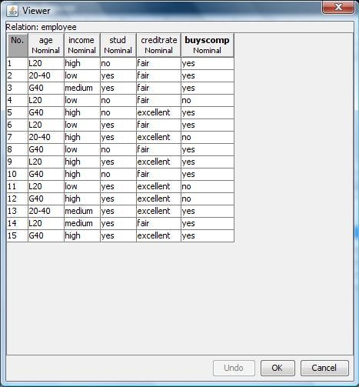

**EXPERIMENT NO:4**

# Creation of Banking Table:

**Procedure:**

1. Open Start → Programs → Accessories → Notepad
2. Type the following training data set with the help of Notepad for Banking Table. @relation bank

@attribute cust {male,female} @attribute accno

{0101,0102,0103,0104,0105,0106,0107,0108,0109,0110,0111,0112,0113,0114,0115}

@attribute bankname {sbi,hdfc,sbh,ab,rbi} @attribute location {hyd,jmd,antp,pdtr,kdp} @attribute deposit {yes,no}

@data male,0101,sbi,hyd,yes female,0102,hdfc,jmd,no male,0103,sbh,antp,yes male,0104,ab,pdtr,yes female,0105,sbi,jmd,no male,0106,ab,hyd,yes female,0107,rbi,jmd,yes female,0108,hdfc,kdp,no male,0109,sbh,kdp,yes male,0110,ab,jmd,no female,0111,rbi,kdp,yes male,0112,sbi,jmd,yes female,0113,rbi,antp,no male,0114,hdfc,pdtr,yes female,0115,sbh,pdtr,no

1. After that the file is saved with **.arff** file format.
2. Minimize the arff file and then open Start → Programs → weka-3-4.
3. Click on **weka-3-4**, then Weka dialog box is displayed on the screen.
4. In that dialog box there are four modes, click on **explorer**.
5. Explorer shows many options. In that click on **‘open file’** and select the arff file
6. Click on **edit button** which shows banking table on weka.

# Training Data Set → Banking Table

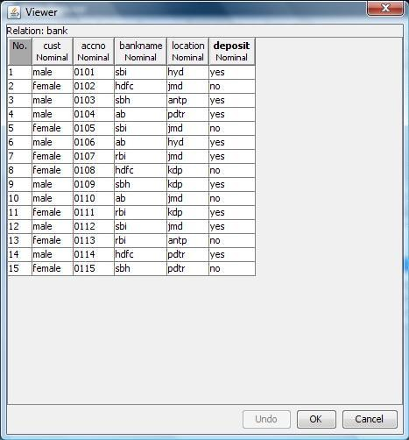

**EXPERIMENT NO:5**

# Creation of Customer Table:

**Procedure:**

1. Open Start → Programs → Accessories → Notepad
2. Type the following training data set with the help of Notepad for Customer Table. @relation customer

@attribute name {x,y,z,u,v,l,w,q,r,n} @attribute age {youth,middle,senior} @attribute income {high,medium,low} @attribute class {A,B}

@data x,youth,high,A y,youth,low,B z,middle,high,A u,middle,low,B v,senior,high,A l,senior,low,B w,youth,high,A q,youth,low,B r,middle,high,A n,senior,high,A

1. After that the file is saved with **.arff** file format.
2. Minimize the arff file and then open Start → Programs → weka-3-4.
3. Click on **weka-3-4**, then Weka dialog box is displayed on the screen.
4. In that dialog box there are four modes, click on **explorer**.
5. Explorer shows many options. In that click on **‘open file’** and select the arff file
6. Click on **edit button** which shows customer table on weka.

# Training Data Set → Customer Table

